1. **What are the four access modifiers available in Java and what is their significance in**

**terms of class, method, and variable accessibility**

Public - The class, method, or variable declared as public is accessible from any other class or package.

Private - The class, method, or variable declared as private is accessible only within the same class.

Protected - The class, method, or variable declared as protected is accessible within the same package and by subclasses

Default - The class, method, or variable declared as default is accessible only within the same package.

**2. What is the difference between Exception and error**

Exception - Event that disrupts the normal flow of program. It can be Recoverable issues that can be handled in the code.

Error - we cannot handle from external issue or fundamental issue in the application.

**3. What is the difference between checked Exception and unchecked Exception?**

Checked Exception - Java itself will know it might throw an exception. Also it will allow the user to handle.

2. Unchecked Exception - It will not make compulsory for user to handle it. If they can, they can handle it or they can leave it unchecked.

**4. Write a Java program that reads user input for two integers and performs division. Handle**

**the exception that is thrown when the second number is zero, and display an error message to the user.**

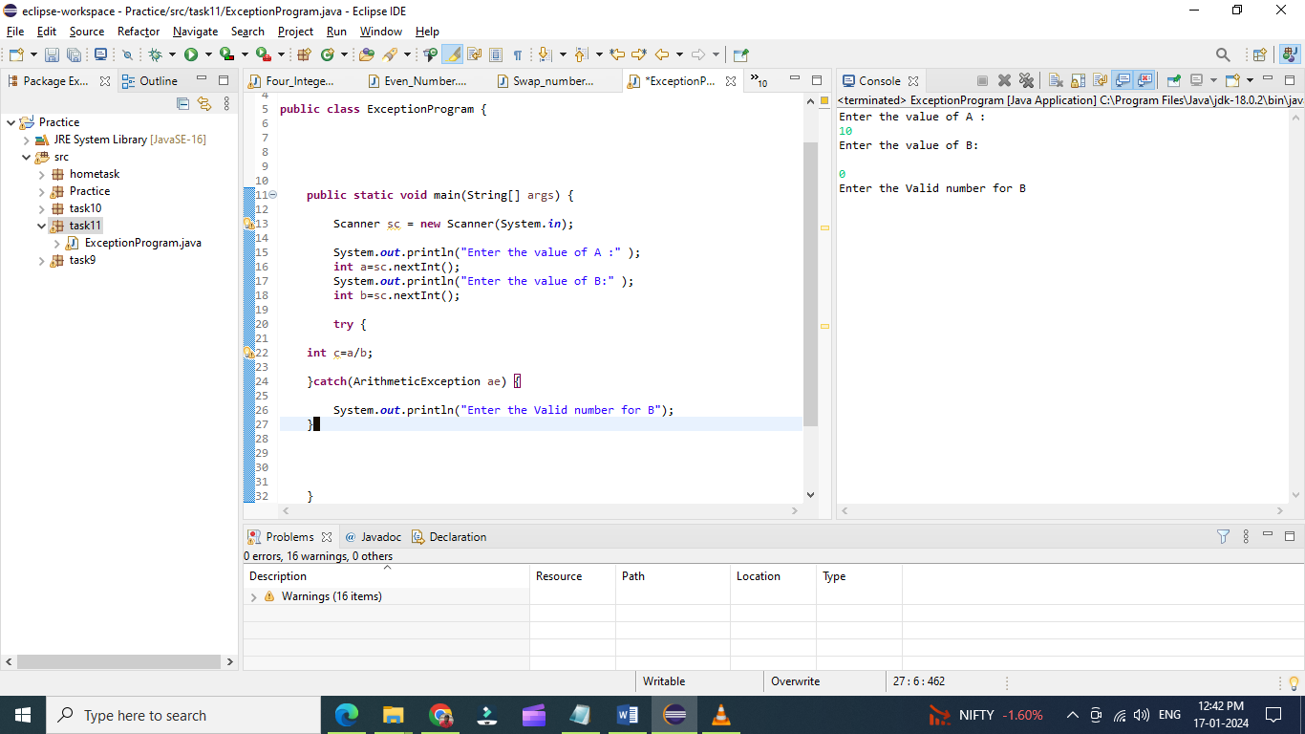

**5.** **Write the code of ArrayIndexOutOfBoundsException & StringIndexOutOfBoundsException**

